**Project Design Phase-2**

**Technology Architecture (Architecture &Stack)**

|  |  |
| --- | --- |
| **Date** | October 2022 |
| **Team ID** | PNT2022TMID05082 |
| **Project Name** | Inventory Management System for Retailers |
| **Maximum Marks** | 4 Marks |

**Technical Architecture:**

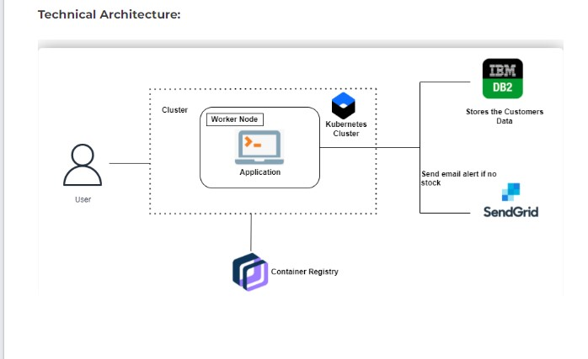

**Table-1: Components and Technologies:**

|  |  |  |  |
| --- | --- | --- | --- |
| **S. No** | **Component** | **Description** | **Technology** |
| 1. | User Interface | How user interacts with application, Ex. Mobile App, Chatbot | HTML, CSS, Python, MySQL, Flask |
| 2. | Application Logic-1 | Logic for a process in the application | Python |
| 3. | Application Logic-2 | Logic for a process in the application | SendGrid |
| 4. | Application Logic-3 | Logic for a process in the application | IBM Watson Application |
| 5. | Database | Data Type, Configuration etc. | MySQL |
| 6. | Cloud Database | Database Service on Cloud | IBM DB2, IBM Cloud |
| 7. | File Storage | File storage requirements | IBM Object Storage |

**Table-2: Application characteristics:**

|  |  |  |  |
| --- | --- | --- | --- |
| **S. No** | **Characteristics** | **Description** | **Technology** |
| 1. | Open-source frameworks | Microweb framework written in Python | Flask |
| 2. | Security implementation | A set of cryptographic hash functions | SHA-256 |
| 3. | Scalable Architecture | Kubernetes is a open source container orchestration system for automating software deployment, scaling, and management. | Kubernetes |
| 4. | Availability | To customize settings for the docker CLI. The configuration file uses JSON formatting. | Docker CLI |
| 5. | Performance | The performance will be high because there will be no network traffics in the application | Kubernetes is cluster |